Liquid Mirror Ferrofluid Modeling:

Equations, Scales, Codes and Data

Version 1 Release

Lockheed Martin Space and University of Arizona

June 28, 2024

Abstract

Contents

1.0 Physical Assumptions and Governing Equations 3

2.0 Mirror Scales and Reduced Equations 5

3.0 Magnetic Field Modeling Code 7

4.0 Fluid Modeling Code 8

4.1 Static Equilibrium Surface Code 8

4.2 Reduction of Full Fluid Equations 9

5.0 Optical Quality Modeling 10

6.0 Summary of Codes and Data Files 11

References 12

# Physical Assumptions and Governing Equations

The physical basis for motion control of a ferrofluid is contained in the quantitative relations of mass and momentum conservation and Maxwell’s equations. These equations take the form:

Incompressible continuity:

|  |  |
| --- | --- |
| $$∇∙v=0$$ | (1) |

Newton’s second law:

|  |  |
| --- | --- |
| $$\frac{∂v}{∂t}+v∙∇v=g-\frac{1}{ϱ}∇p+ν∇^{2}v+\frac{μ_{0}χ}{ϱ}H∙∇H+\frac{γ}{ϱ}κδ(r-r_{s})$$ | (2) |

where the right-hand side consists of these forces: body force (gravity, inertial, external disturbances), pressure gradient, viscous force, magnetic force, and surface tension. $ϱ, χ$ and $γ$ are the ferrofluid density, linear magnetic susceptibility, and surface tension, respectively.

Maxwell’s equation (Ampere’s law):

|  |  |
| --- | --- |
| $$∇×H=J$$ | (3) |

There are many physical assumptions regarding the constitutive behavior of the ferrofluid deployed in these equations and we have taken care to ensure we do not violate these assumptions, namely that our magnetic fields are small relative to saturation so that a linear constitutive relation between the magnetization and external field hold and that all macroscopic dynamics are slow compared to nano-scale changes, meaning that all relaxation phenomena are much faster than relevant dynamics. These complexities are discussed in many texts on ferrofluids [1,2] and we take these relations as our starting point.

The computation domain for these equations directly relates to the general mirror shape and we show this domain in Figure 1. We are aiming for a parabolic mirror and the bottom boundary has this general shape. Magnetic sources exist beneath the bottom boundary creating a field that permeates the entire computational domain, and that is the first task of modeling: generating a field. Once we have a field, we then compute the ferrofluid’s motion subject to this field plus various gravitational and rotational loadings and derive the equilibrium surface shape from this motion. The fluid’s motion back-reaction on the field generation coils and magnets is not considered here, and eventually we will want to use this process to understand what fields we need to create to generate optical quality surfaces and the corresponding field control we will need to compensate for the various body force configurations. Given the free-surface nature of the problem, the computational domain extends beyond the limits of the actual fluid itself; and we track the fluid surface location, applying the surface tension forces only on that boundary and not computing the fluid velocity above the surface.

Figure 1 – Computational domain and relationships to coil locations and mechanical (CAD) fiducial reference points.

Once we have computed the fluid surface shape, we evaluate its optical quality. This goal of an optical quality surface imposes resolution requirements on the computations. As discussed in the next section, the high-resolution and aspect ratio of the fluid domain poses computational challenges and enables some simplifications. The optical quality evaluation is accomplished using standard tools, such as Zemax, to quantify the impacts of the mirror surface on wavefront distortions. This is usually presented in terms of rotational Zernike polynomial coefficients that directly map to RMS wavefront errors.

The boundary conditions for a mirror application involve three different types related to the different boundaries of the ferrofluid constituting the mirror. The fluid forms a thin film-like structure on top of a rigid mechanical support. The fluid-support boundary is either rigid, meaning standard no-penetration, no slip conditions, or porous, with the boundary velocity related to the pressure gradient across the interface [3]. The top surface of the fluid is a free boundary, whose shape is the primary physical output of the modeling. This free boundary has stress continuity conditions across it and is dynamic based on the fluid loading via the body forces. The side boundaries are generally rigid and due to the thinness of the layer, do not impact much of the consideration.

There are multiple coordinate systems used in the computations and tracking these coordinate systems is important for consistent interpretation of the results. There is a global coordinate system related to the overall mirror fiducials that is maintained as part of the CAD system that coordinates the mechanical assembly and 3D printing of parts. There are local coordinate systems associated with the magnets and coils. There is a fluid computational coordinate system chosen for easy treatment of boundary conditions. All of these coordinate systems have different origins, orientations and symmetries suited to their purposes. Linking them and ensuring consistent interpretation is an important system engineering function and currently manifests in the modeling process as the magnetic field is generated separately from the fluid modeling which is distinct from the optical characterization. Recognizing the importance of this headache early in the mirror development process is key to high-quality results.

# 2.0 Mirror Scales and Reduced Equations

The fluid governing equations are a coupled, nonlinear system of partial differential equations with an unknown, dynamic boundary. As such they are a formidable numerical challenge. In addition, the fluid configuration is thin, creating numerical instability and/or performance challenges. We discuss some key aspects of the ferrofluid mirror configuration that can simplify them reduce computational effort for obtaining reasonable answers.

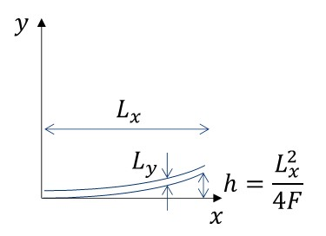The liquid mirror consists of a substrate that has the shape of the desired mirror surface but not of optical quality (see Figure 2). A ferrofluid sits atop this structure and held in place by a combination of magnetic and capillary forces, depending on the nature of the fluid-substrate interface. This fluid layer is relatively thin, and this provides a rough ordering of length scales: $L_{y}≲h≪L_{x}$. As an example of this ordering, consider the mirror slated for development in Phase 2 of this project; its diameter is 0.5 m ( $L_{x}=0.25$ m) and it has an #f = 10, or the focal length $F=5$ m. The depth of the bowl is $h=3.125$ mm. The fluid thickness is designed to be $L_{y}=1$ mm. In this case, the fluid’s radial dimension is larger than its thickness by a factor of 250. This large aspect ratio enables us to make various useful approximations to the overall governing equations. Before making these explicit, further simplifications can be had by examining the properties of the ferrofluids.

Figure 2 The length scales involved with a ferrofluid mirror. The horizontal scale is radius (or diameter) of the mirror and the two vertical scales represent the depth of the bowl that provides the optical power of the mirror and the thickness of the fluid layer.

The first property to investigate is the viscous force of the ferrofluid. The hydrocarbon-based ferrofluids we envision using have a viscosity of around 250-350 cP (Pa m/s) and density of about 1.32 g/cm3. To link this property to our length scales, we can estimate a boundary layer thickness based on a free-fall velocity from the edge of the mirror to the center: $V=\sqrt{2gh}=.247$ m/s, and the Blassius boundary layer thickness in this case is $δ=5\sqrt{{μL_{x}}/{ϱV}}=5\sqrt{{300×0.25}/{1320×0.247}}=2.398$ m. This boundary layer thickness is much larger than any other length scale in the mirror and it gets larger if we use slower velocity estimates. This implies that the viscous force will be prominent in the dynamics. This highly viscous flow regime is called creeping (or Stokes) flow and enables a tremendous simplification of the dynamical equations in the form of being able to drop the acceleration terms in the momentum equation. This linearizes the equations for the fluid velocity.

The next fluid property to understand is the surface tension term. The curvature is related to an inverse length scale (this is the mean curvature, not the Gaussian curvature) known as the capillary length scale: $L_{c}=\sqrt{γ/{ϱg}}$. For our ferrofluids, the surface tension with air is in the range of 40 mN/m, and that leads to a capillary length of $L_{c}=\sqrt{{0.04}/{1320×9.8}}=1.75$ mm, or a little larger than the thickness of the fluid layer. Surface irregularities smaller than this scale will be smoothed out due to this force and that implies that if we can keep the magnetic undulations to smaller than this scale, the ferrofluid surface should be of excellent optical quality.

The last force to examine is the magnetic force. Since we control the size of the magnetic field, we can estimate how big a field we will need to compete with gravity and surface tension. This characteristic field strength is given by an instability threshold called the Rosenzweig instability. The critical field for the onset of this instability, where the magnetic energy becomes larger than gravity and capillarity, takes the rough form $H_{c}^{2}\sim {ϱgL_{c}}/{μ_{0}χ}$. Our ferrofluids have a susceptibility of about 2.5 which yields a critical field $H_{c}\sim \sqrt{{1.32×9.8×1.75}/{1.25×2.5}}×{10}^{3}=2.69$ kA/m which is about 33 G (about 50-100 earth’s natural magnetic field on the ground). The saturation field for our ferrofluids is about 440 G, so we are safely within the linear magnetization regime. The instability is brought about by having the magnetic field *normal* to the surface exceed this value, and readily available permanent magnets can generate fields 10-100 times greater than this. So, the readily available magnetic fields can compete with the other forces to create a balance.

To summarize all this scale analysis, we can safely ignore the convective derivatives in the momentum equation due to the creeping nature of the fluid motion, and the remaining four forces are all of similar magnitudes. Based on the thinness of the fluid, we can also get further reductions: the spatial derivatives scale inversely with the horizontal and vertical length scales: $∂_{x}\sim 1/{L_{x}} ≪∂_{y}\sim 1/{L_{y}}$, so we can certainly ignore horizontal second derivatives. Using these scalings in the continuity equation also implies an ordering to the velocities: $v_{y}\sim \left({L_{y}}/{L_{x}}\right)v_{x}≪v_{x}$, implying that we can focus on computing the horizontal velocity first and continuity will give us the much smaller vertical velocity. Detailed application of these results will appear in the fluid motion section below.

# 3.0 Magnetic Field Modeling Code

We have two approaches to computing magnetic fields: the first approach uses an analytical representation of the magnetic field for a single circular coil [4,5] to build up the total field for an arbitrary distribution of coils, and the second uses ANSYS Maxwell to compute the field of a collection of permanent magnets and arbitrarily shaped currents. All work on the program so far has used the first, circular-coil based approach. Both methods are fully 3D and provide the field distribution in space.

In a coordinate system centered at the middle of the coil of radius $a$, the $z$-axis normal symmetry axis, and the radial direction being the other component (the field is rotationally symmetric), the two field components are given by.

|  |  |
| --- | --- |
| $$B_{r}= \frac{μ_{0}I}{2π} \frac{z}{r} \frac{1}{α^{2}β}\left[\left(a^{2}+\left\{r^{2}+z^{2}\right\}\right)E\left(k^{2}\right)-α^{2}K\left(k^{2}\right)\right]$$ | (4) |
| $$B_{z}= \frac{μ_{0}I}{2π} \frac{1}{α^{2}β}\left[\left(a^{2}-\left\{r^{2}+z^{2}\right\}\right)E\left(k^{2}\right)+α^{2}K\left(k^{2}\right)\right]$$ | (5) |

Where $α^{2}={\left(a-r\right)}^{2}+z^{2}$, $β^{2}={\left(a+r\right)}^{2}+z^{2}$, $k^{2}=1-{α^{2}}/{β^{2}}$ and $E, K$ are the complete elliptic integrals of first and second kind, respectively.

To use these formulas for multiple, arbitrarily positioned coils, we create a local coordinate frame for each coil and project the field point into the local frame and compute the field components which are relative to the local frame and then project the field back into the global coordinate system. Once all the fields for all the coils are computed, we sum the results to generate the total field.

We model permanent magnets as a coil of radius equal to the permanent magnet radius and current sufficient to generate the same field as the permanent magnet. Using this approach, we have been able to match the field distributions we have measured, and those results serve as validation of the code and modeling approach.

Sample of the plots for the 0.5 m mirror concept appear in Figure 3.

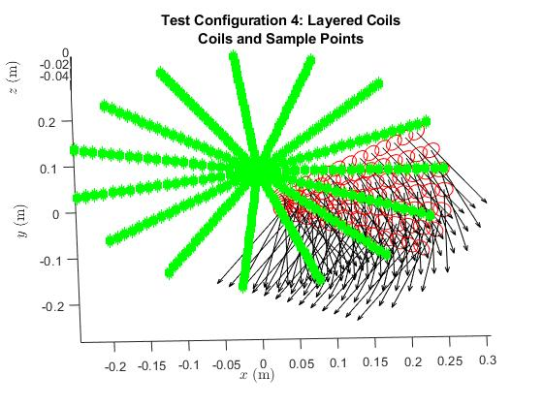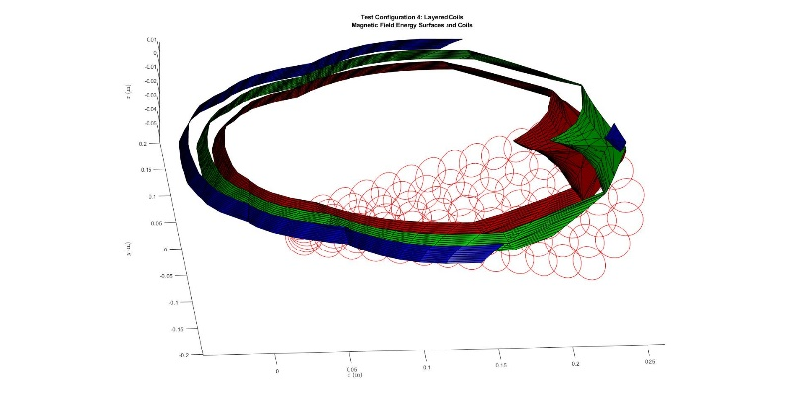

Figure Sample plots from the magnetic field generator code. The coil configuration and sample points appear on the left and the magnetic field potential energy isosurfaces appear on the right.

# 4.0 Fluid Modeling Code

We now discuss the fluid modeling codes we are working on. We have two approaches, one using simplified equations and lower dimensionality in custom code and another using ANSYS Fluent, a robust industrial fluid solver. The high-aspect ratio of the flows involved in the mirror have challenged a straightforward Fluent implementation and our reduced models are informing how to better config it. There are two custom codes: one a static configuration code we discuss next, and one a creeping flow approach. Each of these codes is detailed in the following subsections.

## 4.1 Static Equilibrium Surface Code

Putting $v=0$ in the momentum equation (2) leads to a static balance of gravity, magnetic forces, and surface tension:

|  |  |
| --- | --- |
| $$0=g+\frac{μ_{0}χ}{ϱ}H∙∇H+\frac{γ}{ϱ}κδ(r-r_{s})$$ | (6) |

The body forces contained in $g$ and the magnetic field, $H$**,** implicitly contain the surface function and the curvature is a second-order differential operator of the surface function. This forms an equation that determines the shape of the surface. Manipulating this by integrating across the surface to remove the $δ$-function, his equation takes the form:

|  |  |
| --- | --- |
| $$\begin{matrix}∇^{2}h & = & \frac{2ϱg}{γ}h-\frac{2μ_{0}χ}{γ}H^{2}(x,y,h) \\ & = & \frac{1}{L_{c}^{2}}h-\frac{1}{L_{c}}\frac{1}{H_{c}^{2}} {\overline{H}}^{2}(x,y,h)\end{matrix}$$ | (7) |

a slightly nonlinear equation for the surface height function $h$.The second form we have shown the capillary and magnetic field scales explicitly so that we use these to interpret the numerical values.

To solve this equation numerically, we need to discretize the spatial variables $x,y$ and the height function becomes an array of values on this grid. We need to be able to evaluate the magnetic field at any point in space, and since that field is also discrete on a different grid, we will need to interpolate. The Laplace operator becomes a sparse, banded matrix (tri-diagonal plus two diagonals further out). We start with an initial $h=0$, evaluate the right-hand side of (7), solve the sparse system, re-evaluate the right-hand side, solve that equation and iterate until convergence is achieved. We define converged as changes in $h$ that are less than 10-5, using the capillary scale as the unit of measure. This is about 20 nm resolution, or 1/30th wave, which meets the optical quality measures and is about 10x the measured surface roughness of the ferrofluids from our early lab testing.

The first code we have developed assumes azimuthal symmetry and all variables become a function of radius only. Using the capillary length scale for the radial and height dimensions and the critical magnetic field for its scale, the surface equation becomes a simple ordinary differential equation:

|  |  |
| --- | --- |
| $$\frac{1}{r} \frac{d}{dr}\left(r\frac{dh}{dr}\right)=h-H^{2}(r,h)$$ | (8) |

and this is very straightforward to implement numerically. The boundary condition at the origin is that the slope should be 0 for continuity of the surface at the origin. The outer boundary condition is to specify the location of the surface; physically, this fixes the total amount fluid needed. So, the differential equation (8) is augmented by the two boundary conditions $h^{'}\left(0\right)=0$ and $h\left(R\right)= h_{0}$.

**H=0**: In the absence of a magnetic field, we get a linear differential equation with the solution $h\left(r\right)= h_{0} {\cosh\left(r/R\right)}/{\cosh{1}}$. This is shown in Figure 4 and clearly shows the capillary rise at the outer boundary. This provides high confidence in the code implementation.

## 4.2 Reduction of Full Fluid Equations

The dynamic surface evolution can be handled in multiple ways. We have opted for the “pressure” method with surface advection. The pressure method starts with the bulk momentum equations:

|  |  |
| --- | --- |
| $$\frac{∂v}{∂t}+v∙∇v=g-\frac{1}{ϱ}∇p+ν∇^{2}v+\frac{μ_{0}χ}{ϱ}H∙∇H$$ | (9) |

using a Crank-Nicholoson integrator with an assumed pressure profile. These velocities will not generally satisfy the incompressibility condition and we use the pressure ambiguity to enforce the incompressibility condition. To do that, we take the divergence of equation 9 and enforce $∇∙v=0.$ This leads to a pressure equation of the form:

|  |  |
| --- | --- |
| $$∇^{2}p=-ϱ∇v:∇v+μ_{0}χ∇H:∇H$$ | (10) |

With this pressure update, we re-solve for the velocity and iterate until converged. We then use this velocity field to advect the surface height function (in 2D):

|  |  |
| --- | --- |
| $$\frac{∂h}{∂t}+v∙∇h=0$$ | (11) |

Surface tension is then computed based on the surface reconstruction from the height function and a shape correction applied to minimize the surface energy. This defines the new boundary for repeating the entire computational process. This is a generalization of the computational methods described in [6] to include free-surface and magnetic field effects. The numerical implementation of this algorithm involves staggered variable grids, and is described in [6], [7] and [8]. A variant of this includes dynamic grids that track the surface, in which case, additional terms appear in the equations due to the grid curvature. We did not have time to fully implement and test this.

# 5.0 Optical Quality Modeling

The optical quality modeling converts surface shapes into wavefront distortions. This is accomplished using ANSYS Zemax, which employs sophisticated ray tracing to determine the phase front shape from a reflective surface profile. This is very standard optical modeling approach and there are no custom components for this part of the modeling.

# 6.0 Summary of Codes and Data Files

There are 4 major codes involved in the mirror modeling effort. These codes along with their inputs and outputs appear in Table 1:

Table 1: Codes and Data

|  |  |  |  |
| --- | --- | --- | --- |
| Code | Inputs | Outputs | Dependencies |
| Magnetic Field | Coil configuration  Sample Points | Position and Field Vector at sample points |  |
| Static Surface | Magnetic Field  Substrate Shape  Loading | Ferrofluid surface shape | Magnetic Field |
| ~~Dynamic Surface~~ | ~~Magnetic Field~~  ~~Substrate Shape~~  ~~Loading~~ | ~~Ferrofluid surface shape~~ | ~~Magnetic Field~~ |
| Optical Modeling | Surface shape | Wavefront distortions | Surface shape |

# References

[1] Bashtovoy, V., et. al., *Introduction to the Thermomechanics of Magnetic Fluids*, Hemisphere Publishing, Washington, DC, 1988.

[2] Eringen, C. A., G. A. Maugin, *Electrodynamics of Continua, I & II*, Springer-Verlag, New York, 1990.

[3] Marusic-Paloka, E., I. Pazanin, “The Effective Boundary Condition on a Porous Wall,” Internal Journal of Engineering Science, 173, 103638, 2022. <https://doi.org/10.1016/j.ijengsci.2022.103638>

[4] Simpson, J., et. al., “Simple Analytic Expressions for the Magnetic Field of a Circular Current Loop,” NASA Technical Report Server, 2001. <https://ntrs.nasa.gov/api/citations/20010038494/downloads/20010038494.pdf>

[5] Snow, Chester, “Magnetic Fields of Cylindrical Coils and Annual Coils,” National Bureau of Standards Applied Mathematics Series 38, 1953.

[6] Shyy, Wei, *Computational Modeling for Fluid Flow and Interfacial Transport*, Dover, New York, 1994.

[7] Hinch, E. J., *Think Before You Compute, A Prelude to Computational Fluid Dynamics*, Cambridge University Press, Cambridge, 2020.

[8] Katopodes, N. D., *Free Surface Flow: Computational Methods,* Elsevier, Cambridge, MA, 2019